**Replace Concrete Interfacing Class With Explicit Interface**

|  |  |  |
| --- | --- | --- |
| *a nonabstract class serves as an implicit interface* |  | *replace the inheritance relationship with an explicit interface* |

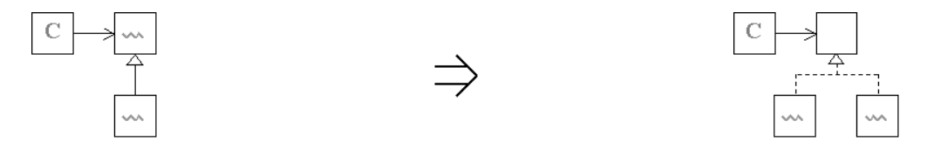

**Context:**

See also : [Replace Concrete Template Class With Abstract Template](https://web.archive.org/web/20090914101053/http:/www.refactoring.be/thumbnails/rtn-rctcwat.html), [Specialize Behavior With Inheritance](https://web.archive.org/web/20090914101053/http:/www.refactoring.be/thumbnails/rtn-sbwi.html), [Rebalancing a Class Hierarchy](https://web.archive.org/web/20090914101053/http:/www.refactoring.be/thumbnails/ec-hierarchy.html)